Tri-County Game Sheet Information Handout

This handout is designed to help OMHA centre contacts, coaching staff and timekeepers with commonly found mistakes made on game sheets to help reduce the errors and to try and avoid unnecessary suspensions due to game sheet errors.

Always consult the OMHA Manual of Operations as information in this handout may change from year to year. Feedback to this handout is encouraged.

Filling out the top of the game sheet:

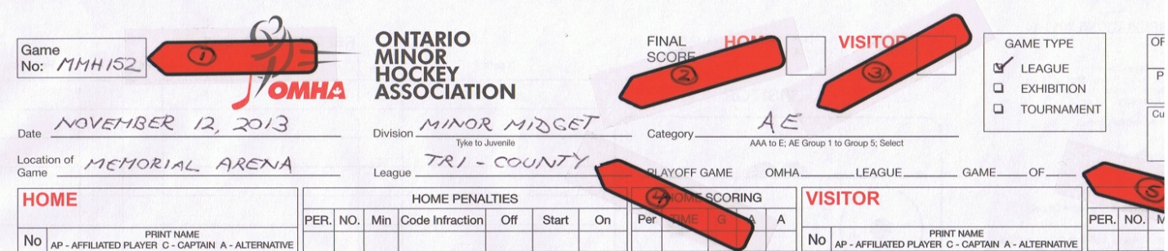

Game Number: This information is often left off the game sheet and makes it difficult for the convenors to track down which game is being played. The number (152) will be assigned to all of your rep teams so the letter prefix is extremely important to include. The information in the letter prefix will let the convenor know both the Division and Category.

ie: MMH – Minor Midget Harrison; AB – Atom Bowen

You will receive different numbers to use during the playoffs.

Division: Self-explanatory. ie: Minor Midget, Bantam, Novice.

For your reference: Division names are AA – Bowen; A – Smith; AE1 – Harrison; AE2 - Russell

Category: In Tri-County please use the category you are playing. AA, A, AE, Select. Please do not use AAA, AA, etc for Tyke Select. Tyke is not considered as rep hockey, but as select hockey so please use Select1, Select2, Select3, etc.

League: Self-explanatory. TRI-COUNTY

Game Type and Playoff Game: Put a check mark in the GAME TYPE box to signify if you are playing a league, exhibition or tournament game. When you are in a playoff game, put a check mark to signify if it is an OMHA playdown game or a Tri-County playoff game.

Length of Game Information:

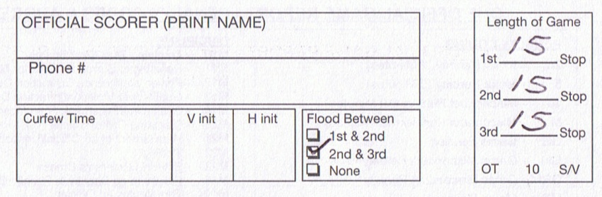

An ideal game would always be 20-20-20 with a flood between both periods but the reality is most centres cannot allot the time required to play a game of that length.

The minimum game length is 10-10-10 stop time.

Increase in the time played per period increases by intervals of 5 minutes and is based on Table 10.2 b found in the OMHA Manual of Operations – Regulations – 10.2 Length of Game:

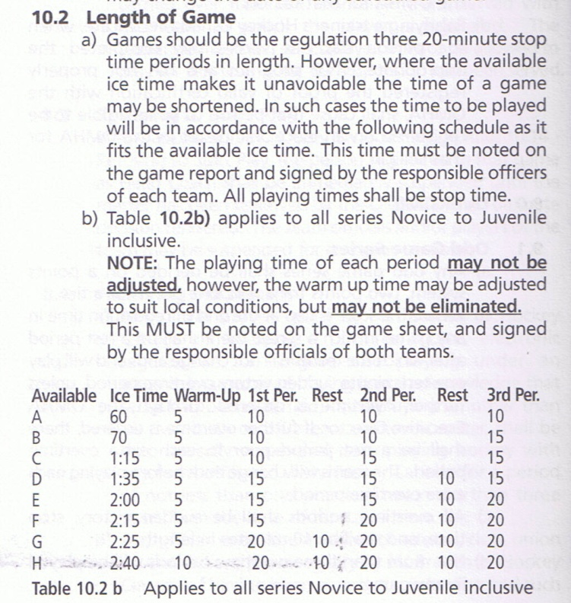

During the regular season, you may find that not all centres will have the same length of periods as your own centre. You may play a 15-15-15 Midget game based on having at least 1 hour and 35 minutes available to play the game as per Table 10.2 b above, but another centre that only has 1 hour and 15 minutes available will only be able to play a 10-15-15 game.

During the playoffs, times will be based on a signed contract before the series or round robins begin.
When Sudden Victory Overtime is used in the playoffs, circle OT 10 S/V (Overtime – 10 minutes – Sudden Victory) found in the Length of Game box.

Filling out the Player information on the game sheet:

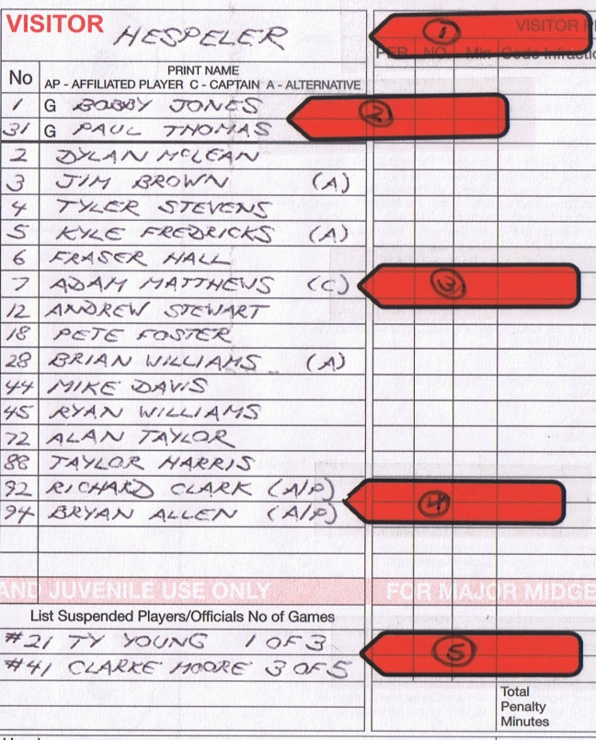

Whether you are writing in the information or using stickers, the following information applies. If you are using stickers, make sure that the sticker does not cover any of the LIST SUSPENDED PLAYERS/OFFICIALS NO OF GAMES box at the bottom.

Please ensure you enter the centre name. Many times this gets left out and if the Game Number is also not on the game sheet the convenor can be left to sort through old game sheets to match up the names.

Make sure to enter both the first and last names of the players clearly. Do not use initials for the first name. If you are using stickers, use (G) beside the name(s) of the goaltender(s).

Please ensure you put (C) beside the Captain and (A) beside the Alternate Captain(s).

Make sure that AP appears beside the names of any affiliated players that participate for your team as per OMHA Manual of Operations – Regulations – 7.2 Affiliated Players. Affiliated players MUST be on an approved AP Roster before they can play as an AP player.

List any suspended players/officials with their full name. Depending on the length of the suspension, list the number of the game being served and the total number of the suspension.

***WARNING*** - When using stickers, ensure that you cross off the names of any suspended players/officials on all four stickers and place the appropriate names in the LIST SUSPENDED PLAYERS/OFFICIALS NO OF GAMES.

***WARNING*** - Failure to cross off the names of any suspended players/officials on stickers and failing to put the names of any suspended players/officials in the LIST SUSPENDED PLAYERS/OFFICIALS NO OF GAMES box can result in further suspension to the Head Coach as per OMHA Manual of Operations – Regulations - 8.0 Suspensions – 8.1 General Information – section i).

Filling out the Coach information on the game sheet:

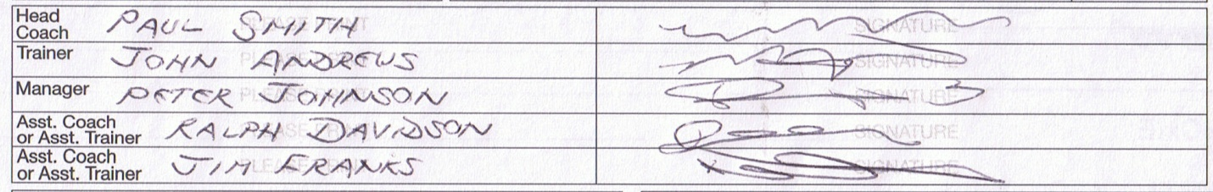

It is strongly recommended that you read and be familiar with OMHA Manual of Operations – Regulations – 6.0 Team Officials.

Under 6.1 Game/Responsibilites – a): The coach in charge of any team must, before any game, PRINT AND SIGN his name on the official game report in the spaces provided for the head coach and he shall be regarded as the responsible officer of the team for that game…..FAILURE TO PRINT AND SIGN HIS NAME ON THE OFFICIAL GAME REPORT SHALL RESULT IN AN AUTOMATIC TWO (2) GAME SUSPENSION TO THE PERSON(S) FAILING TO DO SO.

Under 6.1 Game/Responsibilites – d)iv): Team officials other than the coach in charge must place their name and signature on the game report. FAILURE TO COMPLY SHALL RESULT IN A ONE (1) GAME SUSPENSION TO THE OFFENDING OFFICIAL.

***WARNING*** If an official is not present at the game, do not put their name on the game sheet. Failure to have a signature in the signature box may result in a suspension as noted above. This is especially important when you are using stickers!

Under 6.1 Game/Responsibilities – d): Team officials are designated as Coach, Trainer, Manager, Assistant Coach or Assistant Trainer.

It continues on to explain that on the electronic roster you must have at least two different persons, a coach and a trainer. In addition to the first two, any further rostered persons must be done in the order of Manager, then Assistant Coaches/Trainers. *NOTE* - this is in the same order as is shown in the Coach Information box on the game sheet.

Who goes where on the game sheet?

The rostered Head Coach can only ever appear in the Head Coach position on the game sheet. The Head Coach cannot appear as the Trainer, Manager or Assistant Coach/Trainer on the game sheet.

Only the rostered Manager can appear in the Manager position.

If the rostered Head Coach is not available to be on the game sheet, then an assistant coach must place his name and signature in the top box under Head Coach. If the rostered Manager has the required coaching certification, his name can appear as the Head Coach – in this case the Manager box would remain empty.

If the rostered Trainer is not available to be on the game sheet, then either the Manager or assistant coach/trainer who has the required trainer certification, would place his name and signature in the #2 Trainer position on the game sheet. A team official can only ever appear in one position, at one time, on a game sheet.

If the rostered Trainer is not available to be on the game sheet and there are no other team officials that have the required trainer certification, follow the Single Trainer procedure found in the OMHA Manual of Operations – Policies and Procedures – 2.4 Safety and Risk Management – 2.4.2 Single Trainer.

If the Manager is not available to be on the game sheet, then the Manager box must remain empty.

Under Regulations – 1.0 Definitions –(jjjj): “Team Official at Large” At-large Team Officials (individuals with proper Coach or Trainer Certification) are registered and approved on an Association’s approved “At-Large” Roster when an Association wishes to identify members not otherwise registered and approved on a team’s roster within the Association. These members are eligible to register on a Game Report as Coach/Assistant Coach or Trainer/Assistant Trainer for a team within that Association.

A Team Official at Large cannot go on a game sheet in the Manager position.

Filling in the Penalties section:

Without a doubt, this section has the largest amount of errors and misunderstandings that lead to unnecessary suspensions more than anywhere else on a game sheet!

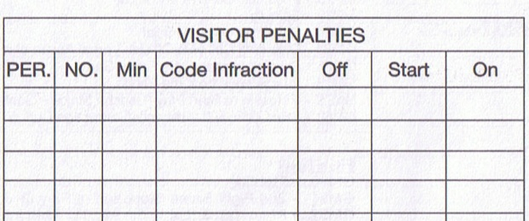

Let us have a look at each item in the penalty section:

PER.: Period 1, 2 or 3 in the regular season.

NO.: The number of the player assessed the penalty (use HC, TR or AC for bench staff).

Min: There are only 3 choices available for the length of the penalty:
2 for a minor penalty
5 for a major penalty or Match Penalty
10 for a misconduct, game misconduct or gross misconduct.
**NOTE** Never put 4 in this box for a double minor such as Head Contact or Spearing. These penalties should be entered as two separate minor penalties of 2 minutes each. We will see why later in this section.

Code Infraction: Use the correct abbreviations that can be found on the back of the game sheet. It is strongly recommended that all timekeepers have a copy of this list readily available to them in the penalty box. The back of the game sheet is always there as a reference.
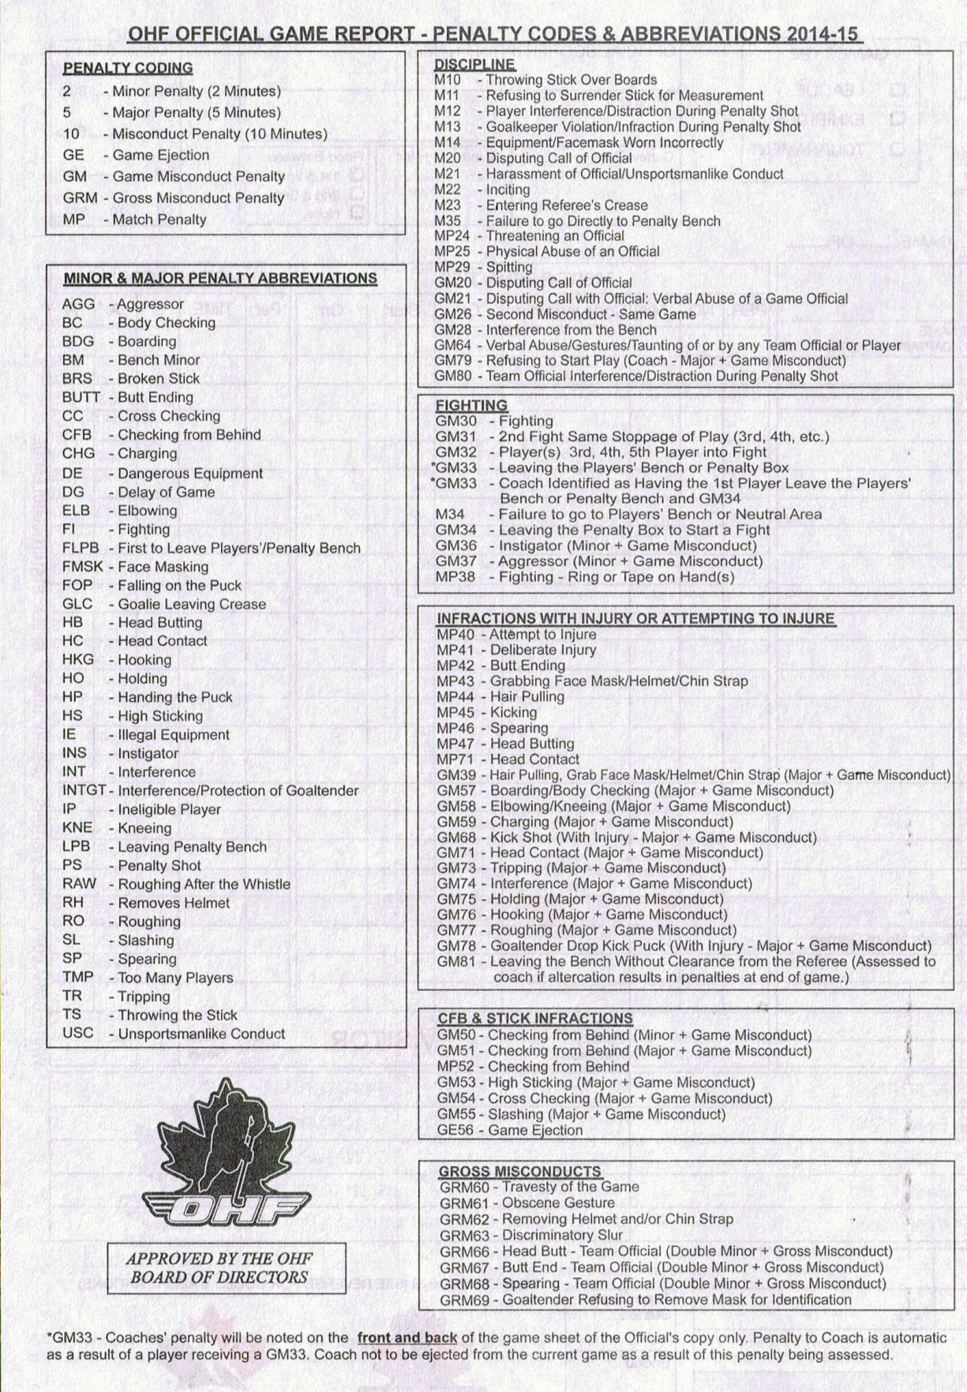
Off/Start/On: Enter the time remaining in the period when the player enters the penalty box (Off), the time that the penalty starts (Start) and the time that the player leaves the penalty box (On).

Let us look at an example where a player receives a double minor for head contact and how these times may vary.

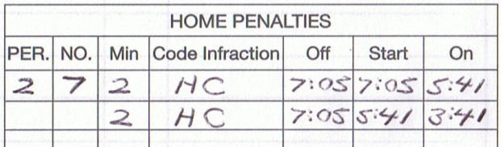

Player #7 on the home team receives a double minor with 7:05 remaining in the 2nd period. Note that the off time is the same for both penalties as this is the time that the player entered the penalty box to serve the double minor. The first penalty also begins at 7:05. If the visiting team does not score a goal during the first of the two minor penalties, then the first penalty would end at 5:05 remaining in the second period and the second minor penalty would begin with 5:05 remaining in the second period. In the case shown above, the visiting team scored a power play goal with 5:41 remaining in the second period. This would bring an end to the first minor penalty and then the second minor penalty would then begin.

The Off and Start time can also be different times when a penalty has been assessed and there are already two penalties currently being served. In this case, the Start time would not begin until the first of the two penalties already being served has been completed.

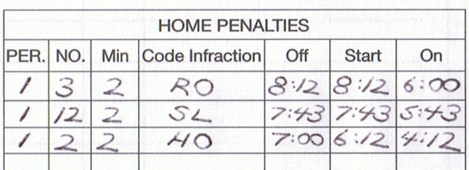

Player #3 receives a roughing penalty with 8:12 remaining in the second period. His penalty begins when he enters the penalty box at this time. Player #12 receives a slashing penalty with 7:43 remaining in the second period. His penalty begins when he enters the penalty box at this time. Player #2 receives a holding penalty with 7:00 minutes remaining in the second period. Since there are already two penalties being served when he enters the penalty box, his penalty will not begin until the first penalty has been served. Assuming in the case above that the other team does not score a goal then the first minor penalty will be completed with 6:12 remaining in the second period and then player #2 can begin to serve his penalty. Notice that player #3 cannot return to the ice when his penalty expires since there are still two penalties being served. He will have to wait until play stops and the whistle blows – in the case above this time was with 6:00 remaining in the second period.

Here is another example when the On time is different from the time that the penalty has been completed. Take the example where two offsetting minor penalties have been called and the teams are still playing 5 on 5 hockey. The players would not be allowed out of the penalty box until the whistle has been blown after the penalties have been completed. When the whistle blows and the players are allowed out of the penalty box, this would become the On time.

Filling in the game sheet for a Game Misconduct Penalty:

Whenever a player receives a major penalty which results in a Game Misconduct, leave three lines open on the game sheet penalty section so it can be filled out as shown below in this example:

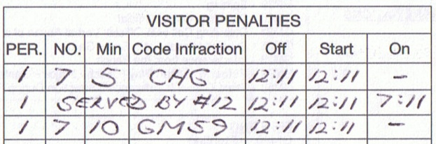

Player #7 on the visiting team receives a 5 minute major for Charging with 12:11 left in the first period. The first line shows the major penalty assessed to player #7. Since the player is ejected from the game with a resulting game misconduct, the second line shows the number of the player serving the major penalty on behalf of the ejected player – in this case player #12. The third line shows the Game Misconduct code for the ejected player – in this example GM59 for Charging.

*** WARNING TO COACHES***

Anytime a player or a coach receives a Game Misconduct (GM), Gross Misconduct (GRM) or a Match Penalty (MP), a resulting number of game(s) will be required to sit in the form of a suspension. You must consult the OMHA Manual of Operations – Suspension List – Minor Hockey to determine the minimum number of games that the player/coach will need to serve. Do not ask the referees what the number of games will be, and do not look on the back of the game sheet. The information on the back of the game sheet will only tell you what the penalty is for that infraction in that game alone, and not the number of games required to sit.

There are two reasons why you should not be asking the referees what the number of games suspended will be:
- Some game misconduct penalties (Fighting/Head Contact) carry an increasing number of games for repeat offences and the referee will not know if this is the player’s first or third offence of the season;
- The number of games shown in the SUSPENSION LIST – MINOR HOCKEY is the minimum suspension required and this number may be increased at the discretion of the convenor.

In the example above for a major charging penalty, the minimum number of games that the player will be suspended for is 2 games (as per OMHA Manual of Operations), whereas the back of the game sheet states that a player that was assessed a GM59 in a game receives a Major + Game – that is the penalty assessed to that player in that game.

It is also possible for a player/coach to be assessed a GM, GRM or MP without a coincidental minor or major penalty being assessed. In this case, only one line needs to be filled out for the GM, GRM or MP.

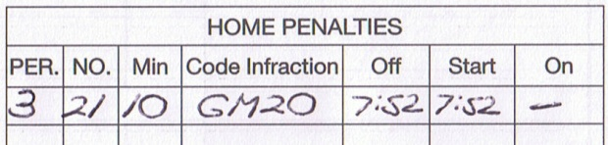

In the above example, player #21 was assessed a GM20 (Disputing Call of Official) without a resulting minor or major penalty.

*** WARNING TO COACHES***

It is extremely important that you are familiar with OMHA Manual of Operations – Regulations – 8.0 SUSPENSIONS – 8.1 General Information – Section f).
This section deals with the situation where a coach shall be automatically suspended from the next OMHA game when his team accumulates more than the allowable minutes in penalties in any game.

Allowable amount for Pee Wee and below is 26 minutes and for Minor Bantam and above is 36 minutes.

“NOTE: For the purpose of the Regulation the time of misconducts, gross misconducts and game misconducts assessed to players shall not be counted, but any such penalties assessed to team officials and the five minutes charged to a player for a match penalty shall be counted. Any misconduct, game misconduct or gross misconduct penalty assessed to team officials will automatically add ten (10) minutes to the team’s penalty minutes in each case.”

Finally, the OMHA normally sends out a reminder just prior to the beginning of the playoffs with regards to miscoded penalties. Here is an excerpt from the last memo:

“This memorandum is being sent to all Member Associations as a reminder relating to miscoded or non-coded penalties on a game sheet.

Be advised that in all cases of miscoded or missing code infractions it still is the responsibility of the team officials to adhere to the requirements of the Suspension List shown on pages (225 and 226) of the current OMHA Manual of Operations. All Major penalty infractions and all Gross Misconduct penalty infractions include suspensions.

Details on how the suspensions are to be served can be found in Regulation 8.2 on pages (118-121) of the current OMHA Manual of Operations. At this point in the season, there are no excuses for suspensions not being served as a result of a coding error. If difficulty is encountered in determining the actual type of suspension penalty from the wording and/or coding, it is the responsibility of the Team Officials to have this clarified so the correct suspension is served. Clarification of the type of penalty assessed may be obtained from the assessing on-ice official. Clarification of the suspension to be served may be obtained through the Centre Contact in consultation with the OMHA Convenor or the Regional Executive Member.

The policy of the OMHA is that all suspension penalties, if miscoded or not coded at all, must be treated as if the coding was present.”

